1. **Experiment:** BLI-based affinity assessment of IL-2 Mimics under acidic conditions
2. **Time:** 2025.06.26-2025.07.10
3. **Member:** Xudong Tang, Yang Jin, Binxuan Zhang, Kaiqing Zhang, Xuantong Liu
4. **Materials:** SA Sensors, Greiner 96-well Black Plate, 0.5M MES buffer (pH=6.0, J62574.AK 2-Morpholinoethanesulfonic acid sodium salt: 71119-23-8), 1.5 mL EP Tubes, 15 mL Centrifuge Tube, Empty Sensor Tray, Octet RED96 BLI instrument, IL-2Rβγ, IL-2 mimics(GALA peptide conjugation)
5. **Method:**
6. Sensor pre-humidification: Pre-wet plates were placed in a blue chassis (corner A1 of the sample plate needed to be snapped into the snap hole of the blue tray), and 200 μL of MES buffer, was added to the well where the sensor was placed. The sensor was placed on the green disk, and then the green disk was snapped onto the blue disk. The sensor needed to be pre-wetted for over 10 minutes.
7. Methods Edit: Within the Experiment Wizard software, the "New Kinetics Experiment-Basic Kinetics" option was selected. Following this, the protocol setup interface was accessed. The Basic Kinetics Experiment window was maximized, and the following five steps were sequentially edited:
8. Plate Definition : In the Plate Definition setup, four sample columns were designated as follows: MES buffer was assigned to the baseline1 step, Load to the loading step, MES buffer to both the baseline2 and dissociation steps, and Sample(B34G35R, B51G35R,B51G9 and IL-2) to the association step. The samples consisted of different test sequences at identical concentrations, with each well being loaded with 200 μg/L of the respective sample. Following the completion of parameter configuration, the experiment was initiated.
9. Assay definition: In the assay definition, the setup steps were followed by first clicking "Add" in the window to include the required analysis steps and set the duration for each one. The following steps were added: Baseline (60s), Loading (120s), Baseline2 (120s), Association (180s), and Dissociation (180s), after which "OK" was clicked to confirm the selections. If any parameter required modification, it was edited by double-clicking. Next, in the "Step Data List," the Baseline step was clicked, the arrow was moved to Baseline to indicate that the detection position for this step on the sample plate would be configured, and then the first column of samples on the sample plate was double-clicked, so that at the start of the experiment, the Baseline step would be detected using the samples in the first column (buffer). The "Assay Steps List" then displayed the first added step, showing that the Baseline analysis was performed using samples from the first column, with "No" indicating the step number, "Sample" representing the analysis location on the sample plate, and "Sensor Type" specifying the sensor selected for analysis. This process was repeated to complete the experimental setup for the entire kinetic analysis.
10. Sensor assignment: In the sensor assignment, the sensor position was configured.
11. Review Experiment: Clicking the buttons allowed browsing the previous or next step of the experiment respectively, enabling preview and verification of all experimental steps.
12. Run Experiment: After the setup was completed, the "Start Experiment" button was clicked. Before the experiment was initiated, it was ensured that the samples and sensors were properly placed and the instrument door was securely closed.
13. Result Analysis: The related data were acquired and processed using the Data Analysis software of the Octet® system. Through this analysis, sensor grams were generated, from which kinetic parameters including KD, Kon, Koff, and steady-state fitting curves were derived. The consistency between the fitted and measured curves was evaluated. If the fitted curve showed strong agreement with the experimental curve, it indicated high quality of the fitting results. Based on these data, a comprehensive assessment of the binding affinity between the test sequences and the receptor was performed.
14. 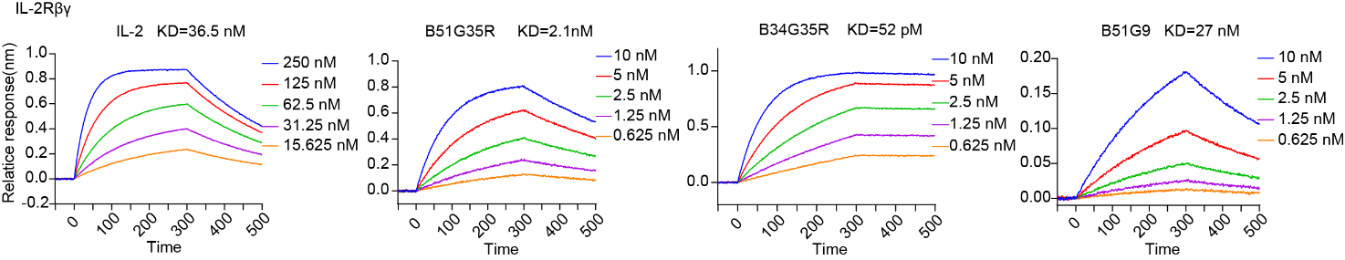**Result:** Under the same acidic concentration (pH=6), B34G35R demonstrates the highest affinity (KD=52 pM), which is higher than that of B51G35R (KD=2.1 nM) and B51G9 (KD=27 nM).

**Figure.1** Bio-layer interferometry characterization of the binding of designed proteins to the corresponding peptide targets.